**Green Society Public School**

**D-24**

**Ratnanagar-7, Sauraha, Chitwan**

**First Terminal Examination-2082**

**Class: Nursery Time: - 2 hrs. F.M.: 50**

**Sub: English ‘W’**

|  |
| --- |
| **Name: Roll No.: Sec.:** |
| **­­­­­­­­­­­­ ________________ ______________ OBT.MARKS:**  **INVIGILATOR EXAMINER** |

**1. Match the letters with the correct pictures. [6]**

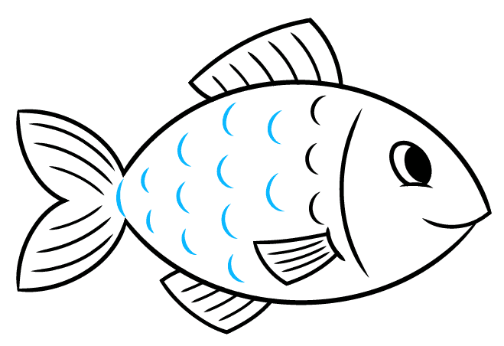

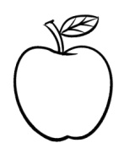A

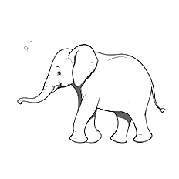F

B

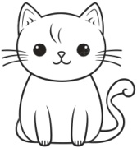C

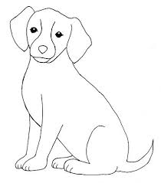D

E

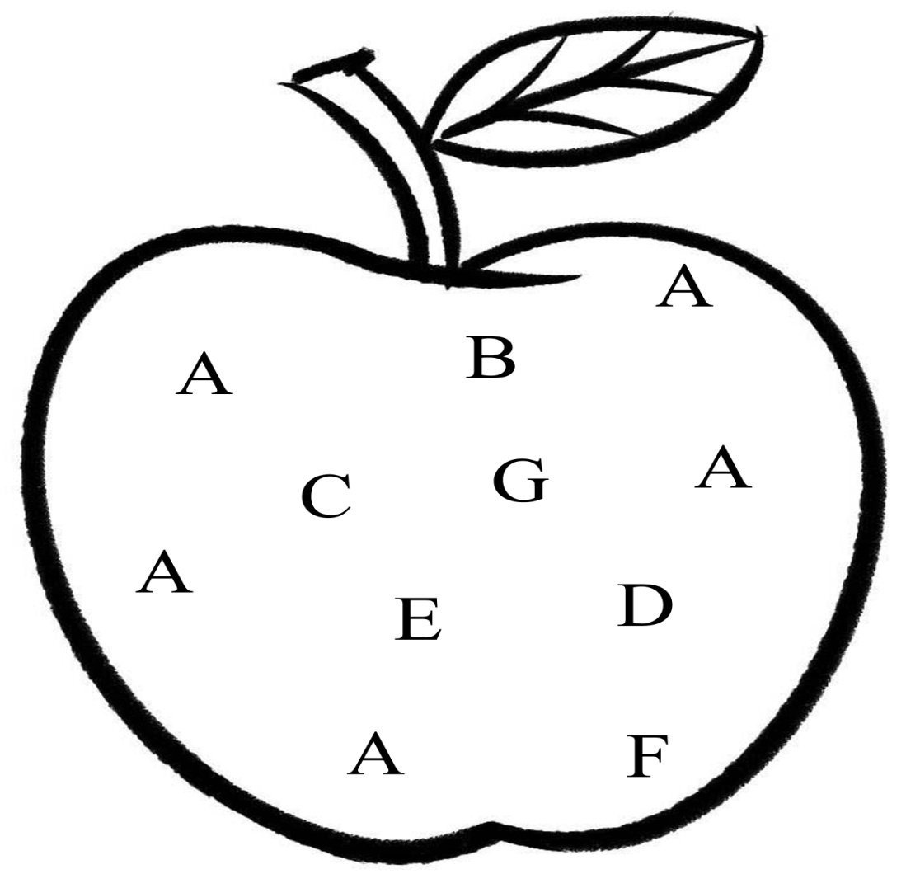**2) Circle the letter ‘A’. [5]**

**3. Match the same small letters. [5]**

d a

a b

b c

c d

e e

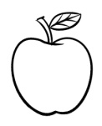**4. Circle the letters according to the given pictures. [5]**

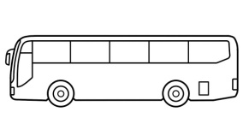 = A U P

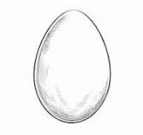 = D B K

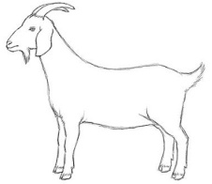 = F B E

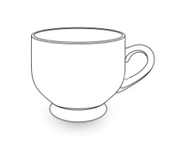 = C G S

= K U C

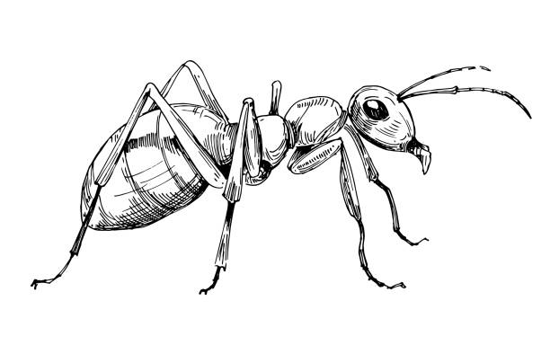**5. Write the first letter of the pictures. [4]**

___________ __________



____________ ____________

**6. Copy the same letters. [12]**

A B C D E F

______ ______ ______ ______ _______ _______

______ ______ ______ ______ _______ _______

**7. Match the same pictures. [5]**





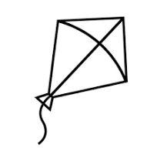





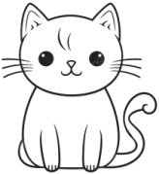

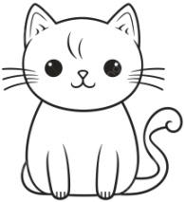

**8. Colour the pictures. [8]**

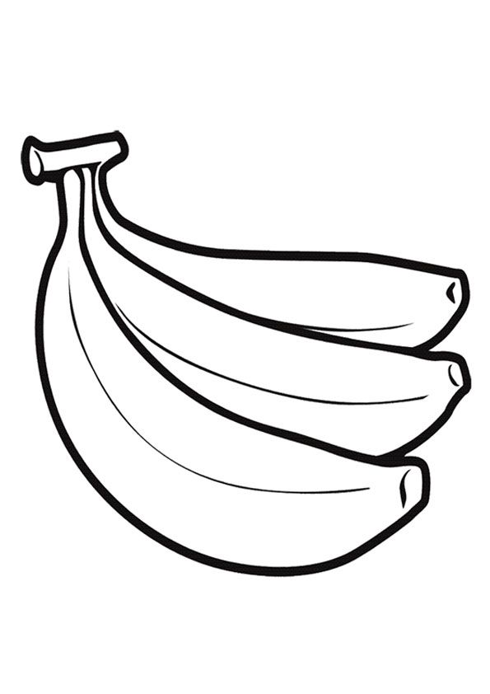

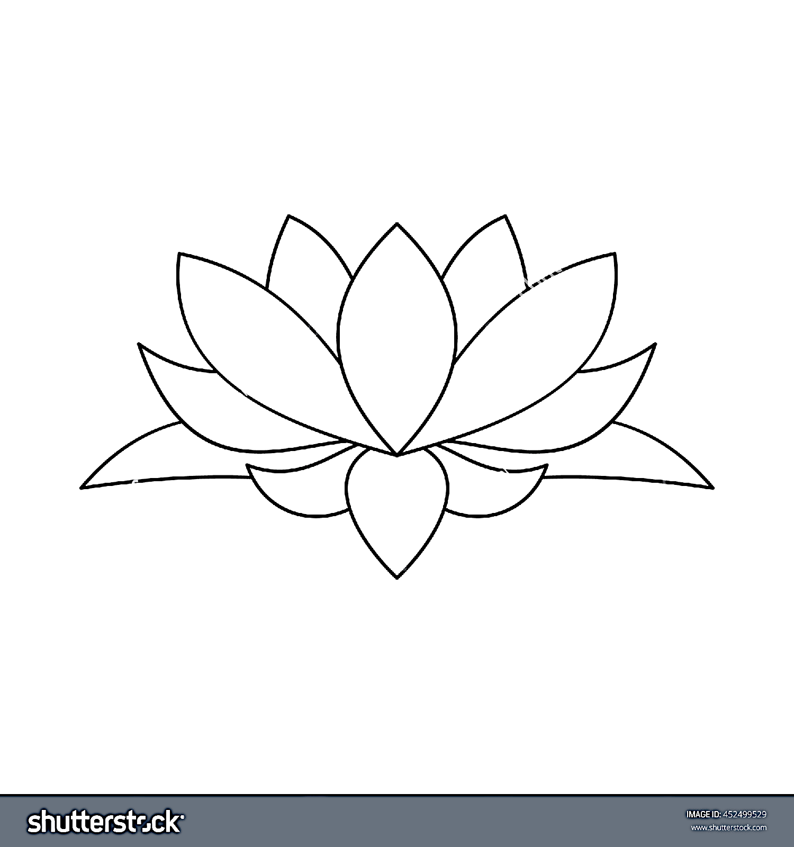

**THE END**